**IAC-21 E 4.3.2**

55th IAA HISTORY OF ASTRONAUTICS SYMPOSIUM (E4) History of Middle Eastern Contribution to Astronautics and Astronomy (3) Author: Mr. Tal Inbar former head of space center at the Fisher Institute for Air and Space Strategic Studies, Israel, [talinbar@fisherinstitute.org.il](mailto:talinbar@fisherinstitute.org.il)

**DAVID – A joint Israeli-German Multi Spectral Small Satellite proposal from the 1990's**

Abstract

The paper will shed light on an obscured Israeli space project of the early 1990’s, that never made it into space. DAVID satellite project was a cooperation between Israel’s ELOP company (Today part of Elbit Systems, the manufacturer of space cameras for all Israeli satellites) and the German company OHB. The DAVID program was the first Israeli attempt to use a specially developed multi spectral camera - to be provided by ELOP, on a small satellite provided by German partner OHB. The Israeli Space Agency was deeply involved in the project, which was supposed to by co-funded by the European Community. The paper will describe the Israeli payload- MSRS: Multi Spectral High-Resolution System, an innovative (at the time of development almost revolutionary) camera with twelve multispectral bands at the near Infrared spectral region. The satellite was supposed to monitor the Earth from a low orbit, mainly for environmental purposes such as agriculture, vegetation, forestry, and Earth resources applications After some year of development, and completion of a series of successful trials on the payload (which was installed on an aircraft) the program came to a stop – mainly due to budgetary issues. It is interesting to note, that decades after the project was terminated such a satellite WAS built and launch on another collaborations – the VENUS satellite, a joint French Israeli project. The paper will use original archival materials from Israel and Germany, as well as testimonies and recollections of prominent ELOP engineers and the director of Israel Space Agency at the time.

**Introduction**

In the framework of the cooperation agreement between the Israel Space Agency (ISA) and the German space agency (DARA, at the time) a study was made of the technical feasibility and commercial viability of a small, inexpensive remote sensing satellite with high spatial and spectral resolution. The name given to the proposed satellite was DAVID, which reflected its substantial capabilities despite its small size.

In a satellite weighing less than 200 Kg, resolution better than 5 meters per pixel, and more spectral resolution than any satellite except Hyperspectral, and with good radiometric sensitivity – the DAVID satellite was revolutionary for its time.

The two principal companies involved in the satellite design were OHB in Germany and EL-Op in Israel[1]. Both have considerable experience in the design, construction, and successful launching of space systems. A second German company, GAF, with expertise in applications of remote sensing products, was also involved in the program.

**Guidelines Principles**

The project principles, as stated in the Phase-A technical presentation were:[2]

* High resolution
* Many spectral bands
* Good sensitivity
* High revisit rate
* Quick delivery of images
* Attractive prices for products

To achieve low prices, the project cost should be achieved by:

* Use of existing sub systems
* Minimum use of moving parts
* Low launch weight
* Compatibility with existing ground stations[3]

To satisfy the requirement for low cost, the basis for the system concept envisages the exploitation and adaptation of existing space rated sub systems although some new satellite and detector technologies was set to be used. The use of moving parts was avoided as much as possible. Low launch weight would be achieved by use of light weight mirrors and composite materials wherever possible.

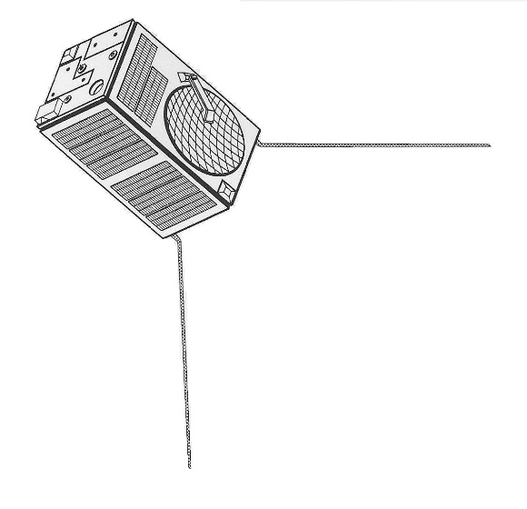Figure 1: ***DAVID satellite rendering[4]***

To reduce the cost of operating DAVID, it was decided to use existing network of ground stations, and that DAVID transmissions will be compatible with those of other satellites like SPOT, to allow ground stations to easily download DAVID images.

**System Requirements**

The aim of the project was to provide a source of remote sensing Earth images that will meet the needs of many existing and potential users. The areas of application for which the data was intended included land and water pollution monitoring, vegetation classification and evaluation, land use characterization – especially in agriculture and forestry, hazard warning and damage assessment as well as other uses which might arise.

One important feature of DAVID was its ability to offer capabilities that were not covered by other satellites at the time: high resolution (better than 5 meters GSD), high spectral resolution (bands of 35 nm or better), good radiometric sensitivity and accuracy and broad spectral coverage in the visible and Near IR with a swath width of at least 30 km.

**DAVID description**

The payload concept was chosen to meet requirements mentioned in previous paragraph, The principal characteristics were:

* Spatial resolution – 5 meters per pixel in nadir
* Spectral region – visible and near IR
* Spectral bands: 12 bands of 35 nm width
* Radiometric resolution – 10 bits

Due to the mission requirements, a sun-synchronous orbit (SSO) at 670 km altitude was chosen. SSO provides optimal illumination conditions throughout the year.

DAVID's sensor was consisted of a mirror type objective with 12 detector channels in its focal plane. Each channel had a TDI (time delay integration) type detector array giving high sensitivity and a separate interference filter for wavelength band definition.

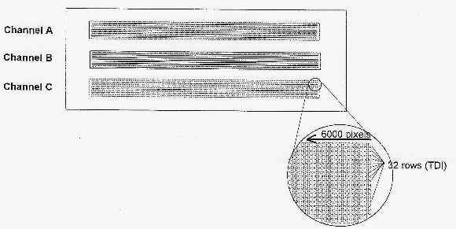

Figure 2: ***Detector unit layout (schematic)***

Pointing of DAVID's sensor to off-nadir angles sideways and forward and rear was to be achieved by orienting the satellite to the required sensor pointing angle. This eliminating the need for a costly scan mirror sub system.[5]

To help preventing smearing in the TDI detector due to the motion of the image (caused be the Earth's rotation) the S/C yaw angle must be oriented so that the TDI is perpendicular to the vector sum of the satellite and the Earth motions. This angle varies with latitude, being about 4 degrees off the satellite track at the equator and about 2.5 degrees at latitude of 50 degrees North or South.

**DAVID design considerations**

The optics was based on a 20 cm telescope objective designed at El-Op for a UV astronomical space telescope (TAUVEX, and see "TUVEX – the odyssey of an Israeli space telescope" by the author[6])

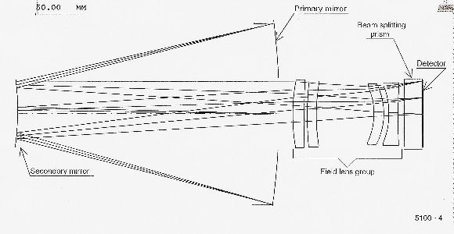Figure 3: ***Optical layout of the 20 cm* telescope**

The Ritchey-Chretien mirror design with field-flattering refractive elements was adapted to the visible light by redesign of the field flattener and the addition of the dichroic beam-splitting assembly. The objective and its structure were designed for very low weight using a light-weighted mirror, beryllium bezel and composite material structure. Its high mechanical stability and dimensional insensitivity to temperature changes enabled the usual focusing mechanism to be omitted, which lead to FURTHER reduction of both weight AND cost.[7]

Optical parameters of the telescope:

* Effective focal length: 160 mm
* Effective pupil diameter: 200 mm
* Field of view: 2.6 degrees
* Obscuration ratio: 0.47
* Spectral range: 400-950 nm
* Overall length: 450 mm (from secondary mirror vertex to focal plane).

**Orbital regime**

For maximizing DAVID capabilities, and meet customer needs, it was decided that the satellite will be launched into a Sun Synchronous Orbit (SSO) at a height of 670 kilometers and inclination of 98.07degrees. This trajectory ensured passing of the satellite at the same time (11:30 AM) and illumination on every pass.

Other parameters were:

* Swath width: 30 km
* Spatial resolution: 5 meters, Nadir viewing
* Slewing capability: 30 degrees off-track and in-track
* Complete coverage cycle: 4 days at +/- 20 degrees latitude; 3 days at +/- 27 degrees latitude
* Re-Visit cycle: 3 days/ 45 orbits
* Orbit decay: smaller than 35 km in five years
* Maximum Northern latitude: 59.5 degrees, in spring and autumn.

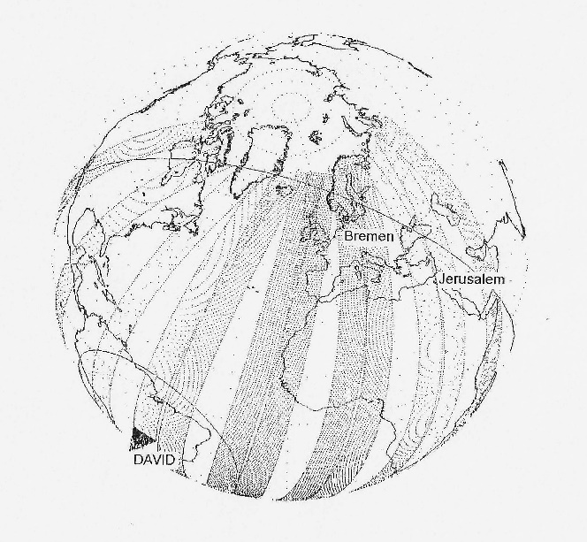Figure 4: ***Usable ground track***

In the Phase A study, it was mentioned that DAVID satellite will be unique in comparison with other remote sensing system of its time by:

* Near real-time data access
* High resolution multi spectral imagery
* More narrow spectral bands than available at the time
* Efficient customer support.[8]

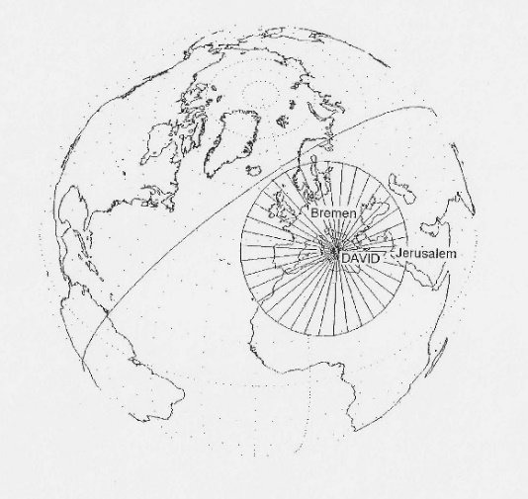Figure 5: ***Antenna footprint: Israel and German ground stations can communicate with the satellite simultaneously***

**Potential Customers**

The potential customers of the DAVID spaceborne compact multi spectral imaging system[9] was researched by the joint Israeli-German team, and consisted of four categories:

* Public Information Services: Disaster management, News, Media
* Environmental management: Pollution monitoring, Hazard zones
* Infrastructure management: Regional planning, Utilities, Cartography
* Resource management: Agriculture (Crop classification and identification, Crop status monitoring, Soil classification), Forestry (Tree classification, Health monitoring), Hydrocarbon monitoring, Fisheries, Coastal zones monitoring.

**Launch options for DAVID**

Because of the wish to make the satellite small and light-weighted as possible, to reduce the cost of the mission, El-Op and OHB were looking for cheap launch options. In the final version of Phase-A technical presentation, two possible launchers were considered:

* ***NEXT*** – Israeli launch vehicle that was derivative of SHAVIT SLV, developed and built by IAI (Israel Aerospace Industries)[10]
* ***COSMOS*** – a Russian small launch vehicle.

NEXT was a proposed 4 stage-launcher, with 3 solid propelled stages and a 4th bi-propellent stage. [11] It was supposed to carry a payload of 290 kg to an SSO at 700 km height. The estimated launch cost was 15 million USD (at 1999 prices).[12]

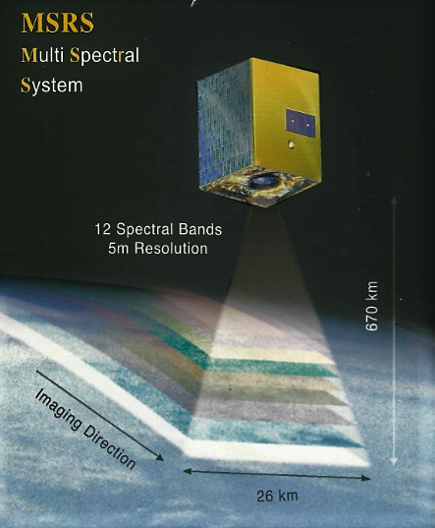

Figure 6: ***DAVID satellite artistic rendering from an El-Op brochure[13]***

**"Spy satellite"? The press coverage that "killed" the program**

In 1993, an article in Israeli newspaper appeared - and in which DAVID was described as a: joint- Israeli-German Spy satellite". The German government suspended the funds for DAVID, which eventually lead to the program termination. In an article from February 11, 2003, the chairman of the Israel space agency, Prof. Yuval Neeman confirmed that Germany "pulled the plug" and that there is no other source to fund the project.[14] After the German government stopped financing the program, an effort was made to continue – with OHB and El-Op own budget, and additional funds from the European 4th framework for R&D (FP 4) – from which 2.3 million Euros were received.[15] More funds were given by the Israel space agency – but not enough to continue the project.

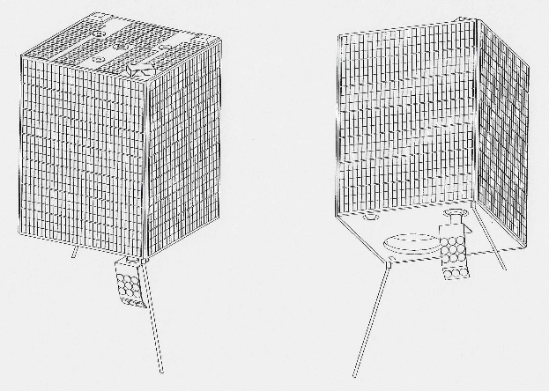Figure 7: **DAVID satellite external views, showing the solar panels (Non deployable)**

**DAVID's legacy**

Although DAVID was never built and launched, several subsystems were built and tested successfully at El-Op. On an interview with Avi Blasberger,[16] who was at the time the head of space products at El-Op, it was clear that the knowledge and experience from prototype camera, detectors, and other sub systems, was very helpful for El-Op on other projects, including the MSC camera (Multi Spectral Camera) that was sold for the Korean satellite *Kompsat-2* in the mid 1990's.

Furthermore – subsystems that were developed at OHB (such as image logger) were eventually made their way to space onboard another satellite (*SAR Lupe*). Perhaps the most vivid legacy of DAVID is the joint Israeli French satellite – **VENμS** (Vegetation and Environment on a New Micro Satellite). A joint study to check feasibility of the program was done on the first half of 2005. Phase A started in 2005 and upon completion, a memorandum of understanding was signed between the ISA and CNES.

the launch date was pushed to 2 August 2017. It was launched via a Vega launcher from Guiana Space Centre together with another Israeli built satellite - OPTSAT-3000 remote sensing satellite sold to Italian MOD.

Venus satellite is **basically a modernized DAVID**, with much better technologies and capabilities:

The satellite has a 2-day revisit orbit which allows constant viewing angles at constant Sun lighting angles. The unique combination is hoped to allow the development of new image processing methods. A set of at least 50 points of interest around the world were chosen to be scanned throughout the scientific mission. The points will be rescanned every 2 days for the entire duration of the mission where it will collect sensory and imagery data. Some of the objectives from the scientific mission are:

* Monitoring and analyzing surface under various environmental and human factors
* Develop and validate various ecosystem functioning models
* Improve and validate global carbon cycle models
* Define theoretical and practical methods for scale transfer
* Collect and analyze data collected by the low spatial resolution sensors

The satellite is equipped with a Super Spectral Camera comprises a catadioptric optical system, a focal plane assembly with narrow band filters, and 4 detector units with 3 separate CCD-TDI array. Each array with separate operational and thermal control.

The satellite is equipped with a Ritchey-Chretien telescope with a focal length of 1.75m and a diameter of 0.25m. Although France was responsible for providing the payload, eventually it was ordered from EL-Op of Israel – and DAVID legacy is evident in all the design parameters.

The experience gained by the DAVID program at El-Op paved the way for the company's capabilities to design, build and test multi spectral payloads, some of them (as mentioned) made the way for space.

The spirit of cooperation with other country certainly helped during the joint projects that came later (Korea, France). And today, more than quarter of a century after DAVID – its legacy lives on in space with more capable and advanced satellites.

1. Later El-Op was bought by ELBIT Systems
2. Slide 2200-3 from DAVID Feasibility study (Phase A) "Technical aspects presentation", restricted/commercial (at the time) document of El-Op, provided to the author by Avi Blasberger, director of Israel Space Agency, August 2021
3. ibid
4. All drawings, unless otherwise mentioned, are from the official Phase A study materials, provided to the author with the courtesy of Avi Blasberger, Director of the Israeli Space Agency and former project manager of DVID at El-Op.
5. This is a design feature in all Israeli remote sensing satellites, and it is also providing stability and agility.
6. IAC-20 E 4.3.2
7. Weight reduction is a feature in all Israeli satellites – due to the need of launching them to the west, due to geographic and safety restrictions. El-Op mastered the technology of light weighted mirrors.
8. Slide 2200-3 of the technical aspect's presentation
9. The official name on the technical documents, as well as just DAVID.
10. This SLV was supposed to be a joint venture with US companies, and was never built
11. A paper on the NEXT launcher and the unique 4th stage will be presented by the author in a future IAC
12. See also Inbar Tal, "To ride a Comet: 25th anniversary of Israel's Shavit SLV", IAC-13 E4.2
13. From the author's archives
14. From GLOBES, Israeli financial daily, retrieved on August 10, 2021: <https://www.globes.co.il/news/article.aspx?did=662275>
15. Ibid
16. On August 11, 2021